**User Documentation**

**Dashboard:**

* + To create a dashboard , Go to dashboards tab at left panel .
  + Select New dashboard button at top right.

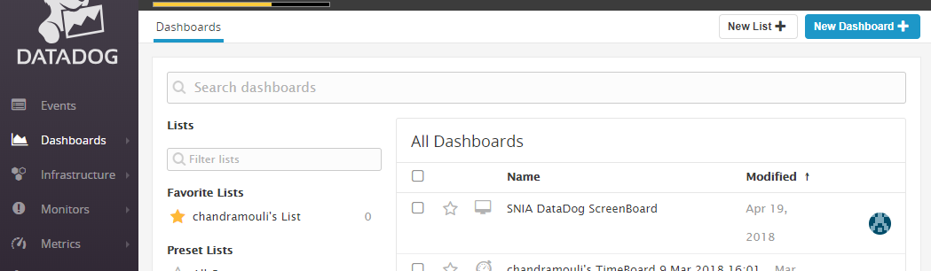

* The below window will open so we have to select any of the dashboard type.
* User should give a dashboard name and select dashboard.

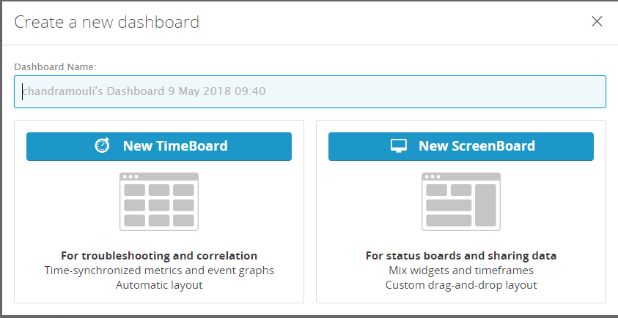

* New Dashboard window will open as shown in below figure.
* Now User can select different types of graphs for visualization.

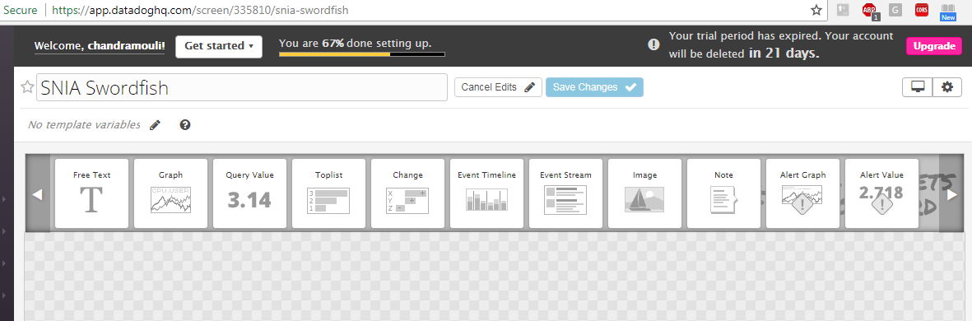

* If user try to select any graph , a window will open as shown in below figure .
* User should edit the graph data and select visualization type to create a gauge.

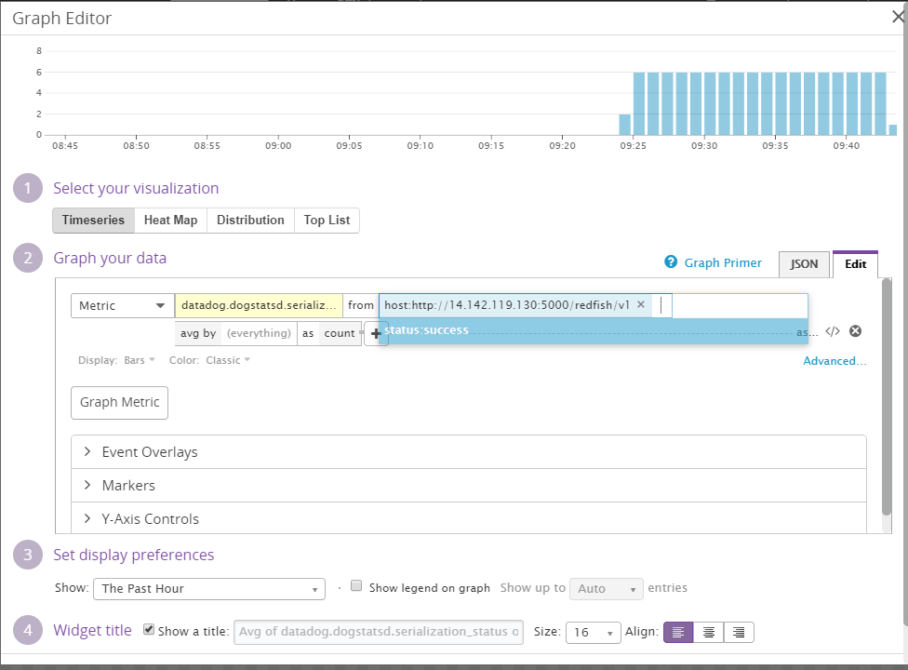

* So , these are the different types of graphs in a dashboard as shown in below figure.
* If user want to modify data , we have to click on edit board button.

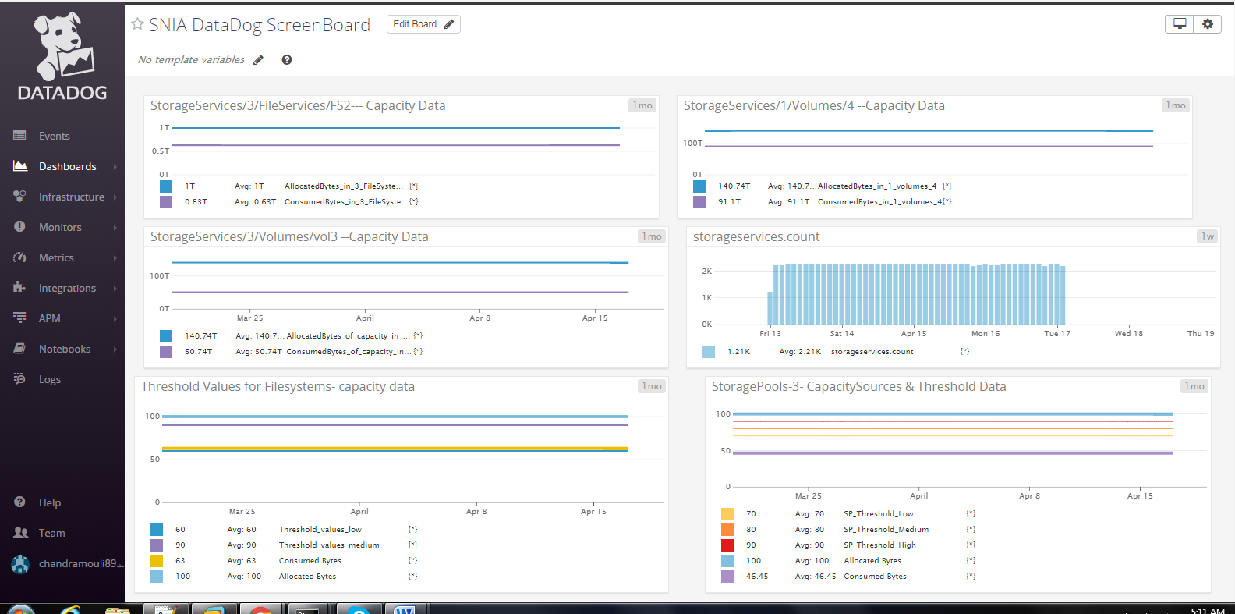

* The below Dashboard shows the Consumed bytes and Allocated bytes data.
* Select the graph from the top menu by editing the menu.

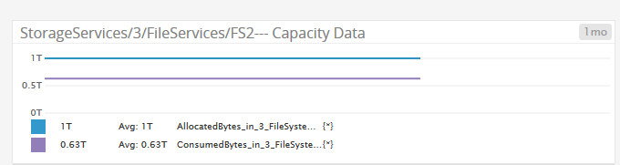

* If a user enters in to graph editor, as shown in below figure.
* User can have options to select visualization and add metrics data.

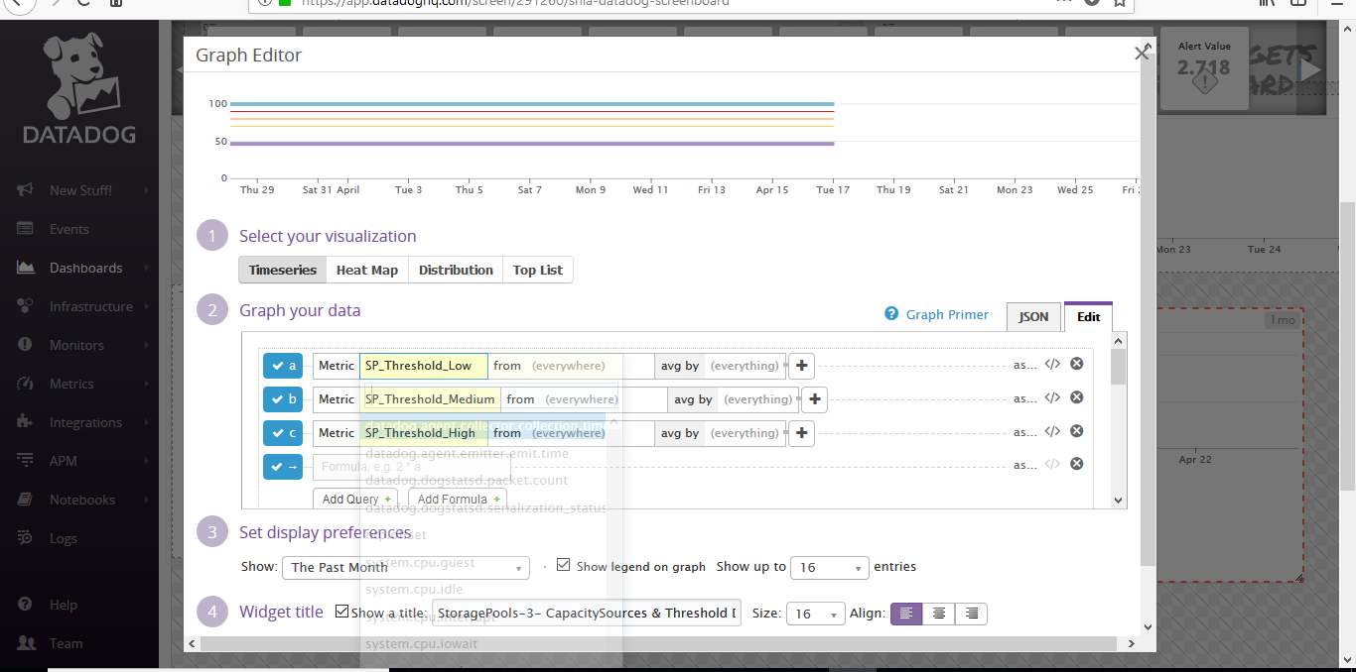

* The below dashboard shows Storage pools data.

